**CENWP-OD-B06 July 2023**

**MEMORANDUM FOR THE RECORD**

**SUBJECT: 23BON044 MFR WA Shore UMTJ RB2 Pacific Lamprey Mortalities**

On 06 July, Bonneville Fisheries discovered two adult Pacific Lamprey mortalities in the UMTJ Rest Box 2 (UMTJ RB2) of the Washington Shore Lamprey Passage System. The fish was scanned for PIT tags, inspected, and returned to the river.

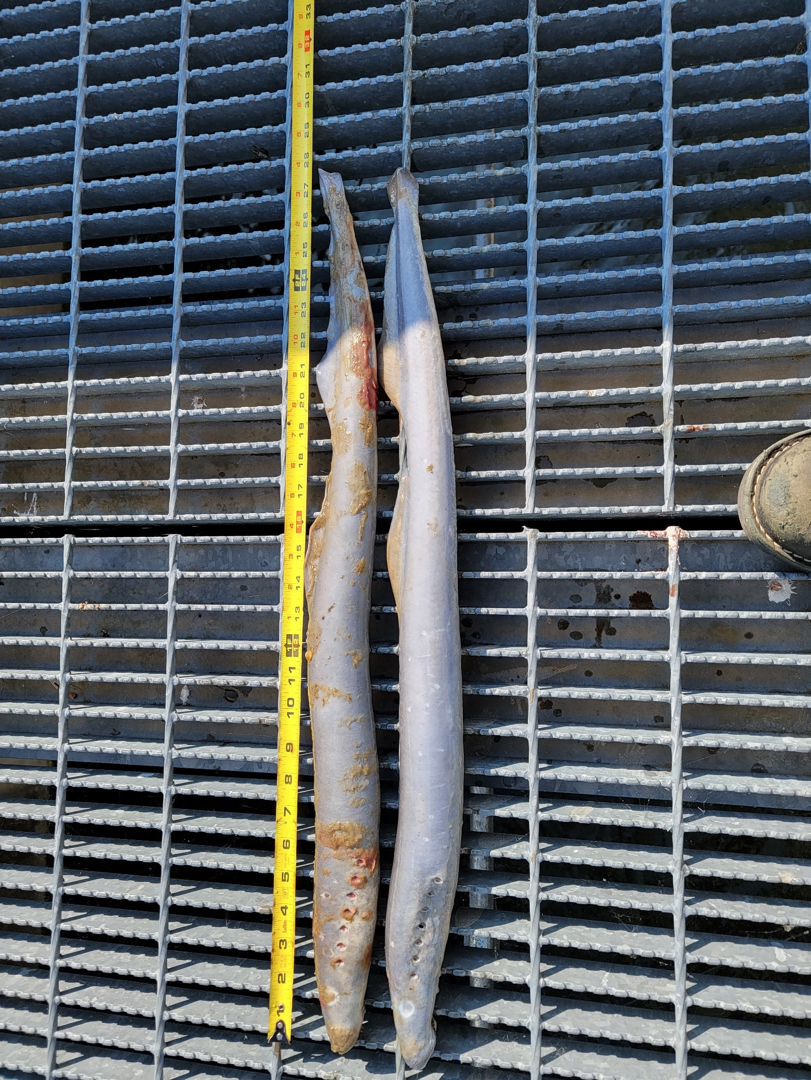

1. Species – Pacific Lamprey (*Entosphenus tridentatus)*
2. Origin – Unknown
3. Length – In descending order: 70.8 cm, 70.5 cm
4. Marks and tags – None
5. Marks and Injuries found on carcass – None
6. Cause and Time of Death – Unknown
7. Future and Preventative Measures – None

Sincerely,

Bonneville Project Fisheries